Brainstorming Stock Ideas

From experience, students get excited and want to buy a stock. It’s worth it to let them pick that initial stock as a team and go through the process of purchasing it. The research components can come later. The students can document their thought process even for that initial purchase. Some examples for the brainstorming and picking a stock:

- Ask your students to list as many companies as they can and keep a class list running on the board or on chart paper. Show the students how to look up these companies on https://finance.yahoo.com/

They will see that some of their companies are not listed such as Chick-Fil-A. https://www.wikipedia.org/ is a great place to find out why. Typing in Chick-Fil-A will result in this: .

Another example is when you search Doritos on https://finance.yahoo.com/ it doesn’t show a ticker symbol. Type it in the Wikipedia site and it will show this: 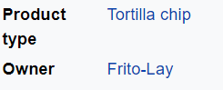.

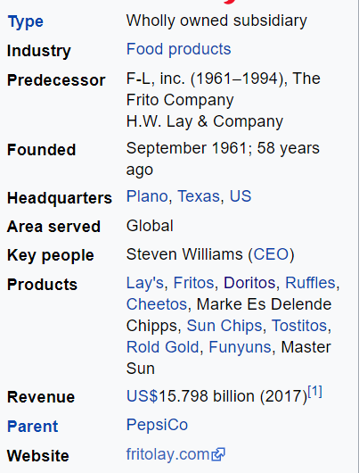
Type in Frito-Lay and it will yield this:
Research will ultimately show that the Parent Company is the publicly traded Pepsico (PEP). This process helps to reinforce the meaning of research (diligent and systematic inquiry or to search and search again) and the research process.
After you have a list of the companies, you can then arrange them by industry. The industry can be found on either https://finance.yahoo.com/ or https://www.wikipedia.org/ .

- Stocks that are companies in your state:
For example: Maryland gives us Under Armour (UA), McCormick (MKC), Stanley Black and Decker (SWK), and many more.
- Stocks that respond to social causes:
For example:
Environmentally friendly stocks – SunRun (RUN)
Stocks that have women CEO’s/Leaders – Mary Barra (GM), Michele Buck (HSY)
Stocks that support Black Lives Matter – NIKE (NKE)
- Stocks that reflect your passion:
For example: Gaming Stocks – Activision (ATVI)

