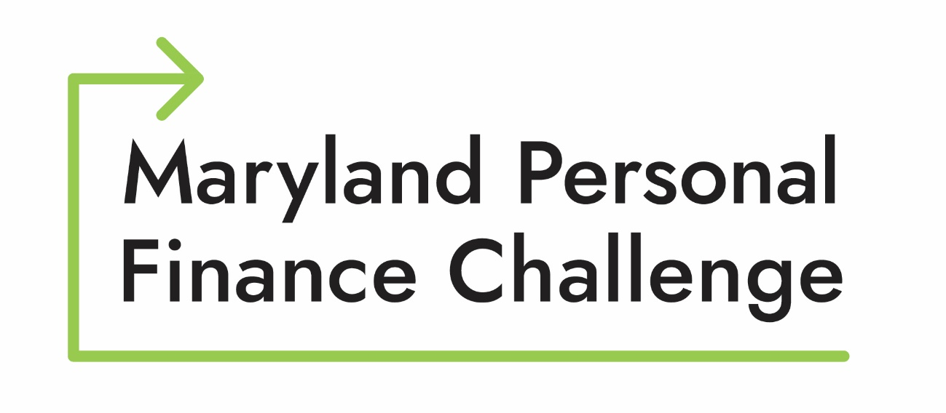

2026 Teacher/Advisor Manual

Presented by



Table of Contents

Competition Overview 3
Prizes 4
How it Works and Timeline 4
Round One 4
Round Two (Finals Round) 5

2026 Competition Dates
Online Testing: Note a student may participate in either the fall or spring testing session, but not both.
- Fall Testing December 15 - December 19, 2025
- Spring Testing: March 19 - March 27, 2026
Maryland Personal Finance Challenge Finals: April 16, 2026, Federal Reserve Bank of Richmond, Baltimore Branch
National Personal Finance Challenge: June 1 and June 2, Atlanta, GA (VOYA Headquarters)

High School Personal Finance Challenge

Competition Overview

The Personal Finance Challenge is an opportunity for high school students to demonstrate their knowledge of personal finance. Students participate in teams of four students. For the 2025 competition year, each school may register an unlimited number of teams. Maryland holds its state competition in April each year. The state winner then goes on to the national competition in June.

The Maryland Council on Economic Education is the sponsor and coordinator of the Maryland Personal Finance Challenge. We take great pride in offering this fantastic learning opportunity for students from across Maryland. With generous support from SECU, Towson University, and others, we can offer this opportunity to students and teachers without cost.

Prizes

Generous prizes are awarded to the top performing teams in the competition. Prizes are in the form of a check payment and are mailed to the recipient’s home address shortly after the competition. State and national winners are invited to be recognized at the Maryland Council on Economic Education’s annual Student Achievement Awards Program.

Maryland Personal Finance Challenge Prizes

1st place $250/team member & teacher
2nd place $125/team member & teacher
3rd place $100/team member & teacher
4th place $50/team member & teacher

*only one teacher and the four participating students per team are eligible for prizes. Alternates are not eligible if they did not compete directly on the winning team.

National Personal Finance Challenge Prizes

1st place $2000/team member
2nd place $1000/team member
3rd place $500/team member
4th place $250/team member

How it Works and Timeline

For 2026, the Maryland Personal Finance Challenge will consist of two rounds. All registered students will participate in Round One. The top eight performing teams in Round One will move on to the second and final round. Only one team from an individual school may advance to the second round.

Round One

Once the first round of the competition begins, students can enter the Finance Challenge website to complete a 40-question, rapid-fire exam consisting of categories on Income and Money Management, Spending and Credit, and Saving and Investing. Students have 45 minutes to complete their individual test. While students do not have to physically take the examination in the same location, students within the same class or club are required to take the test simultaneously.

Please note the following:
- Each student is to complete the challenge as an individual; students do not work as a group.
- A teacher or certified staff member must be in attendance during the entire testing period to ensure that the rules are followed.
- The teacher/certified staff member may not help the student by guiding them or re- phrasing a question. Once the test begins there should be no assistance given to the student.
- Students are only allowed a pencil and scratch paper.
- This is an on-line competition. It is the student's responsibility to secure a computer that can provide an uninterrupted signal to the testing site. The Maryland Council on Economic Education cannot be held responsible for students or teams that cannot complete the test due to computer problems. The test cannot be reset due to computer errors at school or home.
- If testing is held at school, it is the school's responsibility for maintaining an uninterrupted environment for students to test. The test cannot be reset due to circumstances such as bells ringing, fire alarms, students being called out of the classroom or any such event. The school is responsible for providing a proctored testing area. Students must always be supervised by a school staff member.

Round One Scoring

The sum of the top three individual scores on each team make up the team score. Students are awarded 10 points for every correct answer - with a maximum individual score of 400 and a maximum team score of 1200. Teachers will have access to both individual and team scores once the Challenge has been completed.

Round Two (Finals Round)

Shortly after the examination window closes for Round One on March 27, 2026, at noon, the Maryland Council on Economic Education will notify each teacher of an advancing team via email. Rounds Two & Three will take place on April 16, 2026, at the Federal Reserve Bank of Richmond, Baltimore Branch, 8 am – 3 pm.

Round One
- On-line
Multiple
Choice Test
- Top 8 advance to Round Two

- advance to Round Two
Round Two - Case Study

- Case Study analysis
- Top 4 advance to the Quiz Bowl
Round Two - Quiz Bowl

- Quiz Bowl
- The top scoring team is declared the winner

The second (and final) round of the competition consists of two parts: the case study and quiz bowl. The four teams with the top scores from the case study round will participate in a quiz bowl. The winner of the quiz bowl will be declared the winner and will advance to the National Personal Finance challenge.

Case Study: The final round of the competition requires students to demonstrate their knowledge of personal finance topics through analyzing a case study and presenting the results in a formal presentation. Team members are given one hour to create a PowerPoint presentation and are asked to present to a panel of expert judges. Students will be evaluated on the content of the presentation, their presentation skills, and teamwork.

The top two winners will advance to the quiz bowl.

Round Two, Case Study Scoring

A panel of judges will be selected to score each team’s performance in this round. Judges may include economists and professionals with experience in financial planning and financial management.

Judges will use a rubric to score all aspects of each student team’s performance fairly and equally. A copy of the rubric used for judging will be released to registered teams in the spring. However, judges will generally score the following aspects of the case study analysis:

  - Analysis of the case study and response to specific prompts
  - Presentation quality and professionalism
  - Response to judge’s questions

Round Three, Quiz Bowl Scoring

  - One white board answer per team per question.
  - Teams have 20 seconds to consult and have a response written on the white board.
  - Students must write clearly and stop writing once time is called.
  - Hold the board up until judge’s award points for correct answers.
  - One student on each team is designated as the spokesperson for that team.
    - Only responses from the designated spokesperson are considered official.
    - The verbal response must match what is written on the board.
  - Judges have the final say if answers are correct or incorrect.
    - All questions will have been vetted by the FINRA Foundation
  - One point is awarded for each correct answer.
  - There are 30 questions.
  - Round III ends when one team leads by more points than there are questions remaining. If there is a tie, a tie breaker question will declare the winner.

