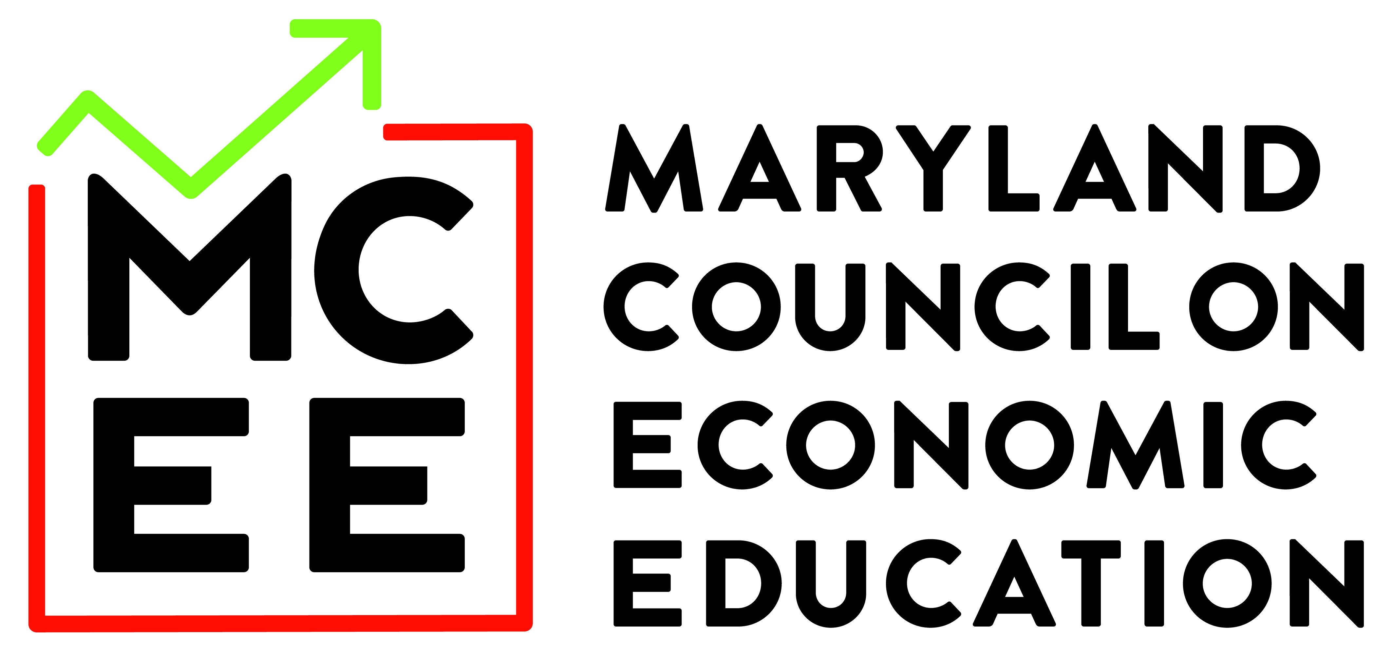

2025-2026 Teacher/Advisor Resources

Preparing for the Competition

Presented by

Preparing for the Competition
As much as you would like to allow students to choose their own teams, we recommend that you strive to field the strongest team or teams you can. You might have some students who have expressed an interest to you, you may advertise within your school to generate interest, or you may hand pick students that you believe would be strong competitors. Actual completion preparation may be done as a class or by working with interested students in a club setting after school. However you decide to work with your students, we recommend that the first thing you want to do is to conduct a pretest. During the time you spend teaching personal finance, you should continue to test and rank your students. When you finally decide to choose the team or teams to represent your school, you can give a posttest and choose the four or eight strongest students. At this time, you might want to spend some time working more intensively with these students. So, in some instances student enthusiasm and willingness to work may trump test performance.

Pre-Test
The resources shown below can be used for pre and post test questions:
- Maryland Personal Finance Pre-test
- ReadyAssessments from the Council for Economic Education. A free and easy-to-use EdTech tool where you can easily access ready-made K-12 personal finance and economics tests and quizzes. The database includes over 1,200 questions along with post-test reports.

How to Prepare Teams
It is important to give your potential teams practice opportunities for both the test and case study analysis. Sample questions are included in this manual. It is a good idea to pattern your practice tests after those they encounter in the competition.
Remember, your goal is to have your students know the material and be able to apply knowledge in a situational analysis. If possible, construct questions that askf the same information in several different ways.

Lessons
- Explore the National Personal Finance Challenge Coach Toolkit – Practice the Six Areas of Knowledge. Within each of the six areas of knowledge you will find lesson plans, activities and a Kahoot quiz.
  - Earning Income
  - Spending
  - Saving
  - Managing Credit
  - Investing
  - Managing Risk

- Econedlink, from the Council for Economic Education has complied a comprehensive set of lessons that correlate to the concepts of earning income, buying goods and services, saving, using credit, investing, and protecting. Lesson plans include videos, PowerPoints, assessments, and activities that can be used to prepare teams or presented in a personal finance classroom.

- Making Personal Finance Decisions Curriculum Unit from the St. Louis Fed. Download the complete curriculum or individual lessons, along with PowerPoint presentations. Units include:
  - Thinking Economically
  - Making Choices and Identifying Costs
  - New Worth & Cash Flow
  - Paying Taxes, Budgeting
  - Saving, Spending
  - Borrowing and
  - Risk Management.
- The Federal Reserve Bank of St. Louis has a PDF version of a set of flashcards containing personal finance questions that would be useful for reviewing concepts.

Videos
- Personal Finance Challenge Speaker Series from MCEE and lessons. Topics include:
  - Risk Management
  - Understanding Fraud and Identity Theft
  - Individual Retirement Accounts
  - Taxes
  - Budgeting

Other Resources
- Better Money Habits from Bank of America includes articles, videos, and tips in both English and Spanish. Advisors might find this resource to be helpful in preparing students for the case study competition. Key topics include Savings & Budgeting, Credit, Investing, Debt, College and Taxes & Income.

The above represents a small portion of the many resources available for teachers to use. If you need suggestions for additional resources, please contact the Maryland Council on Economic Education (MCEE) at mcee@towson.edu or mmetzler@towson.edu.
Case Studies
- NPFC (National Personal Finance Challenge) provides three sample case studies along with a video presentation critique that you can watch with your students. Prior to watching the video, you may want to share this Case Study with your students.
- NGPF Case Studies include teacher and student support guides. Case studies include topics such as checking, savings, type of credit, managing credit, paying for college, budgeting, investing, taxes, insurance, and consumer skills.
- Webinar Using the Case Study Method to Teach Personal Finance presented by NGPF.
Sample Practice Questions
- Maryland PFC Practice Questions

Practice-Sample Questions

- One disadvantage of obtaining furniture or appliances from a Rent-to-Own store instead of purchasing it outright is that with a Rent-to-Own store, the consumer:
a. pays much more for the furniture.
b. must use a credit card to make the purchase.
c. cannot take possession of the furniture until it is totally paid for.
d. usually receives used furniture and not new items.

2. If you cannot make your monthly debt payments, you should:
a. let the creditor turn your debt over to a collection agency.
b. declare personal bankruptcy as soon as possible.
c. skip a payment this month and hope next month is better.
d. contact your creditors to try to work out a modified payment plan.

3. Which of the following is not an example of a personal liability?
a. rent/mortgage
b. checking account
c. credit card balance
d. car loan
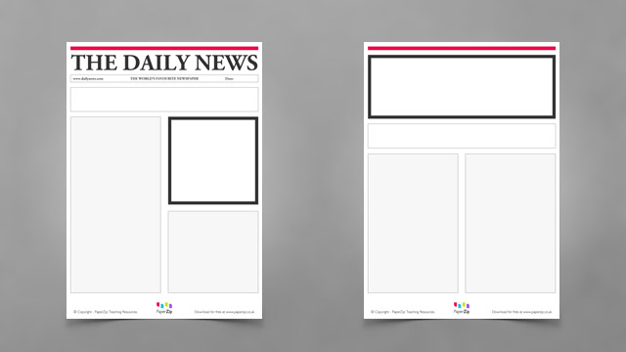
One-Day Sale
Save $19.00!!!!
Yours for only $16.00

4. If you purchased the item referred to in the advertisement above, you actually:
a. saved $19.00.
b. saved over 50%.
c. spent more than budgeted.
d. spent $16.00.
5. The lower a person’s credit score, the more likely it is that he or she:
a. has not declared bankruptcy in the past 10 years.
b. does not need a co-signer to obtain a bank loan.
c. may have benefitted from having no credit history.
d. will pay a higher interest rate on a loan.
6. A “load” mutual fund means that:
a. there is a sales commission charged for investing in the fund.
b. no additional stocks can be brought into the fund.
c. the mutual fund can only be purchased through a licensed broker.
d. there is no minimum amount that can be invested in the fund.
7. All of the following are reasons to buy bonds except:
a. bonds may outperform the stock market during certain periods of time.
b. bonds generally have outperformed the stock market over the last 100 years.
c. bonds pay out interest at set intervals, allowing people to live off the income.
d. investing in municipal bonds may generate less tax liability than investing in stocks.
8. Which of the following savings vehicles does not include a penalty for early withdrawal?
a. Individual Retirement Account
b. 401(k) plan
c. Certificate of Deposit
d. Money Market Account
9. You had 100 shares of McCormick stock, valued at $15.00 per share, and the stock splits 2 for 1. After
the split you now own:
a. 200 shares of MartCo stock worth $1500.
b. 100 shares of MartCo stock worth $750.
c. 200 shares of MartCo stock worth $3000.
d. 100 shares of MartCo stock worth $4500.
10. If you own stock in C&O Railway, which of the following events poses the greatest risk to
your investment?
a. a decrease in demand for the products ABC ships.
b. a natural disaster temporarily shuts down 100 miles of ABC tracks.
c. a new government restriction on the size of loads carried by trucks.
d. a rival train company goes out of business.
11. Bonnie wants to cash her paycheck. The easiest and least costly way to do this is at:
a. a local convenience store.
b. a check cashing company.
c. a credit union where she has an account.
d. a bank where she does not have an account.
12. The longer the waiting period on a disability contract.
a. the higher the monthly benefit.
b. the longer the policy term.
c. the broader the definition of disability.
d. the lower the premium.
13. You receive a telephone call from a collection agency saying you have failed to pay a bill for
nearly $20.00. You explain that the correct name was used but the billing address for the account
was wrong. Which type of fraud is this?
a. Credit-repair scheme
b. Ponzi scheme
c. Identity theft
d. Payday loan
14. The first step in creating a spending plan is to:
a. determine where to invest your retirement savings.
b. record your payments in the appropriate categories.
c. determine where you are currently spending your money.
d. record your insurance premiums in the record book.
15. Which of the following choices would involve the highest opportunity cost for the person making
the choice?
a. A year of high school vocational training taken by a 17 year old.
b. A year of part-time, on-the-job training taken by a mid-career office assistant.
c. A year at a community college taken by a veterinarian’s assistant.
d. A year of refresher courses at medical school taken by a 45-year old doctor.
16. Bill owns a Ford Mustang and while he is backing out of his garage, he is not paying close attention and hits the side of the door, leaving a big dent in his rear bumper. He does insurance with State Farm so when he calls to make claim what part of his insurance policy will he hopefully be able to use to pay for the damage
a. Liability
b. Collision
c. Comprehensive
d. Homeowners
17. As a follow-up to the previous question, if Bill has a $500 deductible in his policy, and the damage to his car is $1,275 how much he will have to pay out his pocket, if anything:
a. $500
b. $775
c. $1,275
d. $0

18. John takes out a fixed rate $88,000 loan from M&T Bank with an interest only rate of 3.5%. How much will he be required to pay at the end of the first year?
a 4,500
b 3,120
c 3,080
d 3,430

19. Jim, who is 60, needs to get cash quickly, but he does not want to incur any tax issue, so which of the following would be the fastest way to get the money in order to pay bills that will be overdue if he waits another week:
- a Sell stock in his company 401K plan
- Cash in stock from personal IRA account
- Get the money from selling stock in his ROTH IRA account
- Take the money from a 3-year CD (Certificate of Deposit) (certificate of deposit) that he has with his bank

20. Once, more, following up to the previous question since Jim is 60, and retired for the past two years, just how much can he invest in either his personal IRA or his ROTH IRA (he is not allowed to do both in the same tax year):
- $6,000
- $6,500
- $7,000
- As much as he wants, since he is retired

