
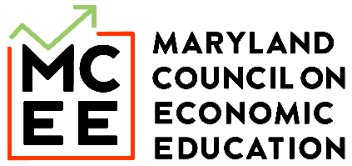

Maryland State InvestWrite Winner - Elementary School
Student: Mauro Pablo Carillo, Grade 5
Teacher: Samantha Gergela
Holabird Academy

What’s your dream for the future? What did you learn in the Stock Market Game that could help you achieve this dream? If you had $10,000 to invest now, what would you invest in, including at least one of your Stock Market Game investments, to achieve your dream in 10 years?

Compound interest is the eighth wonder of the world. He who understands it earns it. He who doesn’t, pays it. -Albert Einstein.

This quote reminds me of the time when a real financial analyst visited our classroom. The analyst was talking about all the tips you need for investing in stocks. Some of the tips were to research what is happening in the news and current events that might impact the stock market. The conversation helped me invest in better stocks. This talk also helped me make more money in my stocks. My teacher helped me invest in a couple of stocks that made me a bit more money.

One dream that I have is to become a doctor, not to make money, but to change my life and my parents. This will impact me because my parents work tirelessly and always come home tired. They sacrificed everything to give me a better life than they had, and this motivated me to work hard and pay them back for everything they did for me. I also want to help my cousins because they help me talk about anything when I am upset.

Learning about long-term investing in the Stock Market Game helped me realize that achieving my goals of being successful is possible but with a lot of patience and smart decisions. By playing the Stock Market Game, it taught me that overtime you can grow your money by a lot and even if the stock market goes down you can always research why it goes up and down. It also helped me realize that you don’t have to sell your companies instantly if they go down.

In my Stock Market Game portfolio, I chose a bunch of different companies to help make sure my stocks don't go down and I profit from them. I picked some well-known companies like (AAPL) Apple because it continues to make new iPhones and the MacBook. (META) Meta because they are popular on social media. (MSFT) Microsoft because it is a strong software business. (NFLX) Netflix because it’s a big company in entertainment, and (SBUX) Starbucks because many people drink coffee in the morning. I picked these companies because they make a lot of sales every day and will keep growing every day.

If I had a $10,000 portfolio, I would separate it to make sure I don’t have any risk and make sure I grow my money. I would invest $5,000 in stable and well-known companies like Apple or Microsoft because they are known for growing. And then my last $5,000 in funds which is a mix of companies that are stable.

In conclusion, the Stock Market Game helped me realize that it's not all about luck, it's about patience, strategy, and smart investing. By making smart decisions I can finally save up for medical school and help my family with everything they did for me. It also helped me realize that the stock market is a tool for my future not a game of investing.

