
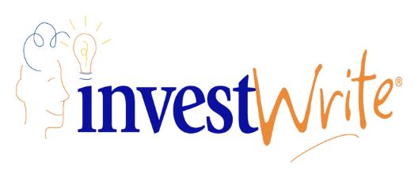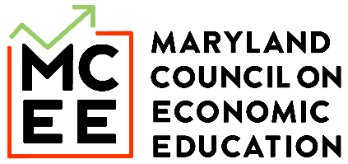

Maryland State InvestWrite Winner - High School
Student: Isabella C
Teacher: Kurt Marx
Stephen Decatur High

What’s your dream for the future? What did you learn in the Stock Market Game that could help you achieve this dream? If you had $10,000 to invest now, what would you invest in, including at least one of your Stock Market Game investments, to achieve your dream in 10 years?

As I continue to grow my academic journey, I have a clear vision for my future. I have many goals I would like to achieve in my life but the current one that I am focusing on is to graduate from college and pursue a career as a forensic neuropsychologist. Forensic neuropsychologist assesses brain functions and behavior in legal cases, providing expert psychological evaluations. They also provide expert assessments, interpret neuropsychological data, and testify in court on issues like competency injury and mental health. This field of neurology is the most fascinating, where it combines psychology, neuroscience, and law. To achieve this goal, I plan to major in psychology, biology, or neuroscience. Through my undergraduate studies, I will find courses and internships that will provide me with a solid base in neuropsychology. This will help give me a boost when I go to get a PH.D in neuropsychology. In addition to my academic pursuits, I am very passionate about playing field hockey. I would love to take my level of playing from high school to college. Playing field hockey at the college level will help introduce me with a healthy amount of stress, which will teach me how to balance my life and reach out for help. This can also help strengthen my discipline, perseverance, and teamwork.

While I participated in the Stock Market Game it was a valuable experience that taught me many essential skills and lessons that will extend way far beyond finance. In the future when I work my way through the academic journey towards becoming a forensic neuropsychologist the Stock Market Game will have provided multiple skills in achieving my goal. One of the most critical skills I developed was risk management. When my team and I started the game, we went for the riskier stocks, such as tesla, but as we worked through the game, we learned to carefully evaluate the potential risks and rewards. This allowed me to learn a lesson about making informed decisions that balanced caution with strategic boldness. This lesson will help me in my future as a student athlete in college, as well as in my career. While I will have to navigate and come to complex ethical dilemmas and make high-stake decisions that impact individual lives. Another crucial lesson I learned was the importance of research and examination before deciding. To make knowledgeable investment decisions, I had to dive deep into company financials, industry trends, market analysis, and social trends. This taught me the value of research and attention to detail, which will be important during neuropsychological assessments and staying up to date with the latest research in my field. Also, the Stock Market Game taught me the value of adaptability and resilience. Stocks can be unpredictable; stocks can go from increasing and having a winning streak of 20 days to losing all the money and value in the business. This taught me to think fast, adjust my strategy as needed, and bounce back from setbacks. These are all the skills I will need in my career as it is very unpredictable and that may require creative problem solving, and flexibility. This can also be used in college sports, when there is a step back or I am losing, I can fight through and help my team come up with new ways to bounce back quickly. Also, while participating in the Stock Market Game, it helped me grow a mindset and love for lifelong learning. I was constantly researching new knowledge, analyzing data, and changing the plan. This game has allowed me to understand that learning is a continuous process, and there is always room for improvement. Whether this is through seeking help through my teammates, professor, or learning it myself. I can stay on top of the latest research and advancements in my career. This growth mindset will not only help in my goal for the future but lifelong.

If I had $10,000 to invest in stocks to achieve my dream in 10 years I would invest in S&P 500, which my group and I invested in the SMG, I would also invest in Microsoft, and Meta. My stock market group invested in S&P 500 because this is a safe stock that is promising. This stock is made up of 500 of the largest publicly traded companies located in the US. S&P 500 has diversification, because it covers companies across multiple industries this allows for less risk of a single stock, therefore if one company is doing bad it won’t affect the stock too much. This would be an intelligent stock to invest in for the next 10 years to achieve my dream because while the stock price does fluctuate, it has a promising payout ratio. I would also invest in Microsoft and Meta in the light of the fact that AI is increasing. We have only used/found AI to its .1% ability, this allows for a lot of growth for new technology to be invented. With this new technology there will need to be companies that make this new tech, this will allow people to buy the new inventions. This will allow for the stocks in these companies to increase. Microsoft and Meta are two of the bigger companies that are creating these new inventions and new updates allowing for AI to grow. With this being said over the next 10 years those two companies, Meta and Microsoft, will create a lot of new technological improvements in AI. This will allow for stock market growth, allowing me to gain a lot of money.

To become a forensic neuropsychologist, I will need to go through lots of schooling. It takes an average of 10-13 years of post-secondary education and supervised clinical neuropsychology experience. This will take a lot of time and money, with stocks in S&P 500, Microsoft, and Meta I can gain money from these investments allowing me to pay my student loans.

